# Experimental values and uncertainties of PDR parameters
# Second line for each isotope - uncertainties of corresponding quantities in the nearest upper line
# Parametes are defined within different methods. For details see ref.

# Z | A | ElId | Er1 | Wr1 | Cs1 | RatioTrk |  | Ref.1 | Ref2
# |  |  | dEr1 | dWr1 | dSr1 | dRatioTRK
# |  |  | [MeV] | [MeV] | [mb]
Z | A | Element | 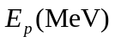 | 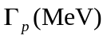 | 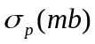 | 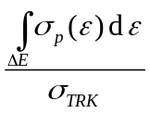 (%)  Integrated strength TRK | Подгоночная функция | REF | REF 2
20 | 40 | Ca | 6.8 |  |  | 0,02 |  | Savran2013 | →Hartmann2004
 |  |  |  |  |  | 0,003
20 | 44 | Ca | 7,1 |  |  | 0,39 |  | Savran2013 | →Hartmann2004
 |  |  |  |  |  | 0,07
20 | 48 | Ca | 8,4 |  |  | 0,33 |  | Savran2013 | →Hartmann2004
 |  |  |  |  |  | 0,04
28 | 68 | Ni |  |  |  | 5,04 |  | Savran2013 | →Wieland2009
 |  |  |  |  |  | 1,51
34 | 78 | Se |  |  |  | 1,97 |  | Savran2013 | →Schramm2012
38 | 88 | Sr |  |  |  | 0,70 |  | Savran2013 | →Schwenger2007
38 | 88 | Sr |  |  |  | 2,40 |  | Savran2013 | →Schwenger2007
 |  |  |  |  |  | 0,60
40 | 90 | Zr |  |  |  | 0,54 |  | Savran2013
40 | 90 | Zr |  |  |  | 2,22 | The Lorentz curve with a constant width | Savran2013 | → Schwenger 2008
 |  |  |  |  |  | 0,38
40 | 90 | Zr | 9 | 2 |  |  | Breit-Wigner function | Schwenger 2008
40 | 90 | Zr | 9.15 | 2.91 |  | 2,1 | Lorentzian function | Savran2013 | →Iwamoto2012
 |  |  | 0.18 | 0.64 |  | 0,2
40 | 90 | Zr |  |  |  | 0,93 |  | Savran2013
 |  |  |  |  |  | 0,09
50 | 112 | Sn | 6.60 |  |  | 0,29 |  | Savran2013 | →Ozel2007
50 | 116 | Sn | 6.40 |  |  | 0,35 | Breit-Wigner function | Savran2013 | →govaert1998
50 | 116 | Sn | 8,000 | 1,40 |  | 1,70 | Gaussian | Toft2011
 |  |  | 0,100 | 0,10
50 | 116 | Sn |  |  |  | 1,78 |  | Savran2013
 |  |  |  |  |  | 0,42
50 | 117 | Sn |  |  |  | 1,78 |  | Savran2013
 |  |  |  |  |  | 0,81
50 | 117 | Sn | 8,000 | 1,40 |  | 1,70 | Gaussian | Toft2011
 |  |  | 0,100 | 0,10
50 | 118 | Sn |  |  |  | 1,86 |  | Savran2013
 |  |  |  |  |  | 0,81
50 | 118 | Sn | 8,200 | 1,40 |  | 1,80 | Gaussian | Toft2011
 |  |  | 0,100 | 0,10
50 | 119 | Sn |  |  |  | 1,78 |  | Savran2013
 |  |  |  |  |  | 0,81
50 | 119 | Sn | 8,200 | 1,40 |  | 1,70 | Gaussian | Toft2011
 |  |  | 0,100 | 0,10
50 | 120 | Sn |  |  |  | 0,25 |  | Savran2013
50 | 121 | Sn | 8,400 | 1,40 |  | 1,8(+1-5) | Gaussian distribution | Toft2011 | (в Савране те же данные)
 |  |  | 0,100 | 0,10 |  | +0,1-0,5
50 | 122 | Sn | 8,600 | 1,40 |  | 1,8(+1-5) | Gaussian distribution | Toft2011
 |  |  | 0,200 | 0,10 |  | +0,1-0,5
50 | 124 | Sn | 6.65 |  |  | 0,64 | Breit-Wigner function | Savran2013 | →govaert1998
50 | 129 | Sn |  |  |  | 2,49 |  | Savran2013 | →Klimkiewicz2007
 |  |  |  |  |  | 0,76
50 | 130 | Sn |  |  |  | 5,10 | Gaussian and/or Lorentzian | Savran2013 | →Adrich2005  →Klimkiewicz2007
 |  |  |  |  |  | 1,76
50 | 130 | Sn | 10,100 | <3,4 |  | 7,00 | Gaussian and/or Lorentzian | Adrich2005
 |  |  | 0,700 |  |  | 3,00
50 | 131 | Sn |  |  |  | 4,97 |  | Savran2013 | →Klimkiewicz2007
 |  |  |  |  |  | 1,76
50 | 132 | Sn |  |  |  | 2,78 | Gaussian and/or Lorentzian | Savran2013 | →Klimkiewicz2007
 |  |  |  |  |  | 1,76
50 | 132 | Sn | 9,800 | <2,5 |  | 4,00 | Gaussian and/or Lorentzian | Adrich2005
 |  |  | 0,700 |  |  | 3,00
50 | 133 | Sn |  |  |  | 5,80 |  | Savran2013
 |  |  |  |  |  | 1,76
50 | 134 | Sn |  |  |  | 2,59 |  | Savran2013
53 | 128 | I | 5,200 |  |  |  |  | Igashira1986
54 | 136 | Xe |  |  |  | 0,85 |  | Savran2013 | →Savran 2011
55 | 134 | Cs | 5,600 | 1,97 |  | 1,20 | Лоренц+затухающая часть | Igashira1986
 |  |  |  |  |  | 0,60
56 | 134 | Ba | 2,824 |  |  |  |  | Fransen1998 | →maser1996_54
56 | 136 | Ba | 3,436 |  |  |  |  | Fransen1998 | →Metzger1978
56 | 138 | Ba | 6.49 |  |  | 0,89 | Lorentzian | Savran2013 | →Volz2006
 |  |  |  |  |  | 0,016
56 | 138 | Ba |  |  |  | 1,31 |  | Savran2013
 |  |  |  |  |  | 0,25
56 | 138 | Ba | 4,026 |  |  |  |  | Fransen1998 | →Herzberd1995
56 | 138 | Ba | 6,490 |  |  | 0,89 |  | Volz2006
 |  |  |  |  |  | 0,16
57 | 139 | La | 6,5+9,0 |  |  | 2,20 | Lorentzians of 0.1 MeV width  and of an energy-dependent width according to  Г= αE2 MeV with α = 0.014 MeV−1. | Savran2013 | →Makinaga2010
 |  |  |  |  |  | 0,41
58 | 140 | Ce |  |  |  | 0,35 |  | Savran2013
58 | 140 | Ce | 3,643 |  |  |  |  | Fransen1998 | → herzberg1997, 1995
58 | 140 | Ce | 6,280 |  |  | 0,38 | Lorentzian | Savran2013 | →Volz2006
 |  |  |  |  |  | 0,07
58 | 142 | Ce | 2,187 |  |  |  |  | Fransen1998 | → herzberg1997
59 | 142 | Pr | 1,500 | 0,84 | 0,04 | 0,02 | Лоренц+затухающая часть | Igashira1986
 |  |  |  |  |  | 0,01
60 | 142 | Nd |  |  |  | 0,21 |  | Savran2013
60 | 142 | Nd | 3,425 |  |  |  |  | Fransen1998 | →Pitz1990
60 | 142 | Nd | 6,070 |  |  | 0,22 | Lorentzian | Volz2006
 |  |  |  |  |  | 0,04
60 | 144 | Nd | 2,185 |  |  |  |  | Fransen1998 | →Eckert1997
60 | 146 | Nd | 1,377 |  |  |  |  | Fransen1998 | →Pitz1990
60 | 148 | Nd | 1,023 |  |  |  |  | Fransen1998 | →Pitz1990
60 | 150 | Nd | 0,853 |  |  |  |  | Fransen1998 | →Pitz1990
62 | 144 | Sm |  |  |  | 0,21 |  | Savran2013
62 | 144 | Sm | 3,226 |  |  |  |  | Fransen1998 | →Wilhelm1996  →Metzger1976
62 | 144 | Sm | 5,690 |  |  | 0,23 | Lorentzian | Volz2006
 |  |  |  |  |  | 0,04
62 | 148 | Sm | 1,465 |  |  |  |  | Fransen1998 | →Metzger1976
62 | 150 | Sm | 1,166 |  |  |  |  | Fransen1998 | →Metzger1976
62 | 152 | Sm | 0,963 |  |  |  |  | Fransen1998 | →Metzger1976
62 | 154 | Sm | 0,921 |  |  |  |  | Fransen1998 | →Metzger1976
64 | 156 | Gd | 1,243 |  |  |  |  | Fransen1998 | →Pitz1989
64 | 156 | Gd | 1,367 |  |  |  |  | Fransen1998 | →Pitz1989
64 | 158 | Gd | 1,264 |  |  |  |  | Fransen1998 | →Pitz1989
64 | 160 | Gd | 1,224 |  |  |  |  | Fransen1998 | →Pitz1989
64 | 160 | Gd | 1,966 |  |  |  |  | Fransen1998 | →Pitz1989
65 | 160 | Tb | 2,700 | 1,00 | 0,30 | 0,09 | Лоренц+затухающая часть | Igashira1986 | →Margraf1995
66 | 160 | Dy | 1,489 |  |  | 0,045 |  | Fransen1998 | NNDC online data bank
66 | 162 | Dy | 1,276 |  |  |  |  | Fransen1998 | ?
66 | 162 | Dy | 1,983 |  |  |  |  | Fransen1998 | ?
66 | 164 | Dy | 1,675 |  |  |  |  | Fransen1998 | →Margraf1995
67 | 166 | Ho | 3,100 | 1,00 | 0,20 | 0,08 | Лоренц+затухающая часть | Igashira1986
 |  |  |  |  |  | 0,04
68 | 164 | Er | 1,387 |  |  |  |  | Fransen1998 | →Maser1996_53
68 | 166 | Er | 1,663 |  |  |  |  | Fransen1998 | →Maser1996_53
68 | 168 | Er | 1,786 |  |  |  |  | Fransen1998 | →Maser1996_53
68 | 170 | Er | 1,825 |  |  |  |  | Fransen1998 | →Maser1996_53
69 | 170 | Tm | 3,500 | 1,00 |  |  | Лоренц+затухающая часть | Igashira1986
70 | 172 | Yb | 1,599 |  |  |  |  | Fransen1998 | →Zilges1990
70 | 172 | Yb | 2,210 |  |  |  |  | Fransen1998 | →Zilges1990
70 | 174 | Yb | 1,711 |  |  |  |  | Fransen1998 | →Zilges1990
70 | 176 | Yb | 2,027 |  |  |  |  | Fransen1998 | → Fransen Diploma thesis
70 | 176 | Yb | 2,163 |  |  |  |  | Fransen1998 | →Fransen Diploma thesis
71 | 176 | Lu | 3,500 | 1,70 | 0,44 | 0,19 | Лоренц+затухающая часть | Igashira1986
 |  |  |  |  |  | 0,1
72 | 178 | Hf | 2,248 |  |  |  |  | Fransen1998 | →Pietralla1997
72 | 178 | Hf | 2,334 |  |  |  |  | Fransen1998 | →Pietralla1997
72 | 180 | Hf | 2,582 |  |  |  |  | Fransen1998 | →Pietralla1997
72 | 180 | Hf | 2,712 |  |  |  |  | Fransen1998 | →Pietralla1997
73 | 182 | Ta | 4,700 | 1,00 | 0,80 | 0,26 | Лоренц+затухающая часть | Igashira1986
 |  |  |  |  |  | 0,13
74 | 184 | W | 2,056 |  |  |  |  | Fransen1998 | →Herzberg1993
76 | 190 | Os | 2,297 |  |  |  |  | Fransen1998 | → Fransen Diploma thesis
76 | 192 | Os | 2,478 |  |  |  |  | Fransen1998 | →Krischok, diploma thesis
79 | 198 | Au | 5,600 | 1,70 | 30,00 | 1,22 | Лоренц+затухающая часть | Igashira1986
 |  |  |  |  |  | 0,61
80 | 201 | Hg | 5,500  (6.0) |  |  |  |  | Igashira1986 | → Bergquist1962
81 | 205 | Tl | 5,400 |  |  |  |  | Igashira1986
82 | 207 | Pb | 5,200 |  |  |  |  | Igashira1986
82 | 208 | Pb |  |  |  | 2,01 | Lorentz | Savran2013 | →Schwenger2010
 |  |  |  |  |  | 0,08
82 | 208 | Pb | 6,82 |  |  |  |  | Savran2013 | →Poltoratska2012
 |  |  | 0,02
82 | 208 | Pb | 7,900 |  |  | 1,2 |  | Lanza2011

C. Fransen, Diploma thesis, Universita¨t zu Ko¨ln, 1997

Пероначальный список литературы

References in the data files
----------------------------
[Igashira1986]
Igashira, M., et al. "Systematics of the pygmy resonance in keV neutron capture ?-ray spectra of nuclei with N? 82u126." Nuclear Physics A 457.2 (1986): 301-316.
[Savran2013]
Savran, D., T. Aumann, and A. Zilges. "Experimental studies of the pygmy dipole resonance." Progress in Particle and Nuclear Physics 70 (2013): 210-245.
[Adrich2005]
Adrich, P., et al. "Evidence for Pygmy and Giant Dipole Resonances in Sn 130 and Sn 132." Physical review letters 95.13 (2005): 132501.
[Fransen1998]
Fransen, C., et al. "Systematics of low-lying electric dipole excitations in the A? 130u200 mass region." Physical Review C 57.1 (1998): 129.
[Lanza2011]
Lanza, E. G., et al. "Excitations of pygmy dipole resonances in exotic and stable nuclei via Coulomb and nuclear fields." Physical Review C 84.6 (2011): 064602.
[Toft2011]
Toft, H. K., et al. "Evolution of the pygmy dipole resonance in Sn isotopes."Physical Review C 83.4 (2011): 044320.
[Volz2006]
Volz, S., et al. "The photoresponse of stable N= 82 nuclei below 10 MeV." Nuclear Physics A 779 (2006): 1-20.

Данные из статей по подгонке

Igashira 1986
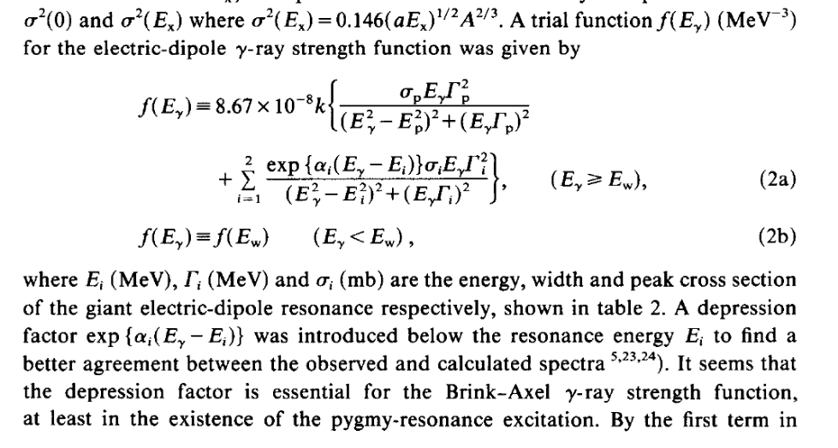

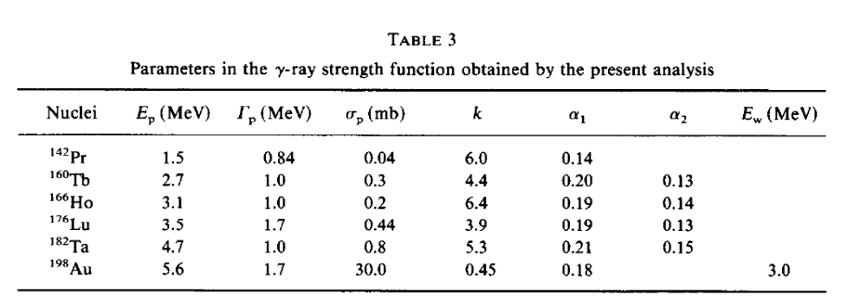

Adrich2015
In order to extract quantitative information, a Lorentzian distribution of photo-neutron cross section was tentatively adopted to account for the GDR and a Gaussian (or alternatively
a Lorentzian) distribution for the apparent lowlying component; below, for convenience, the latter is denoted as PDR.

Govaert1998
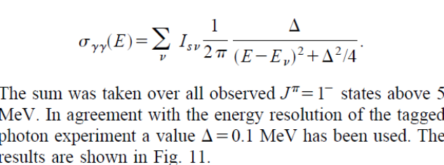

Makinaga2010
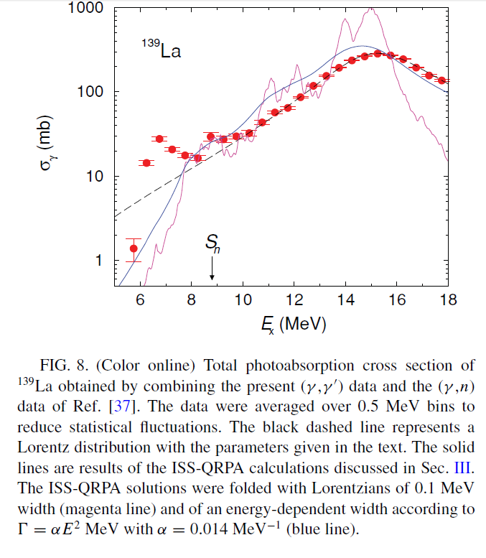

Schwenger2010
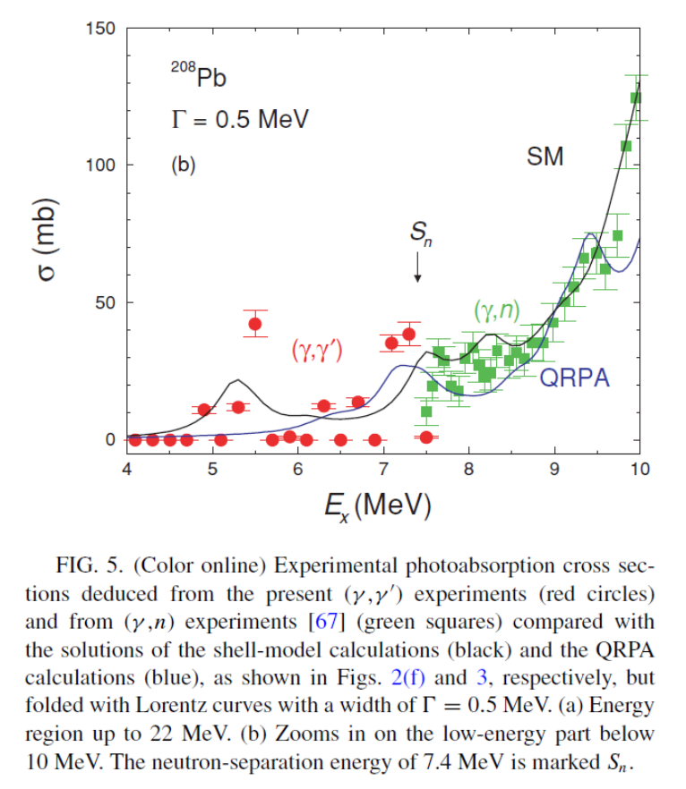

Toft2011
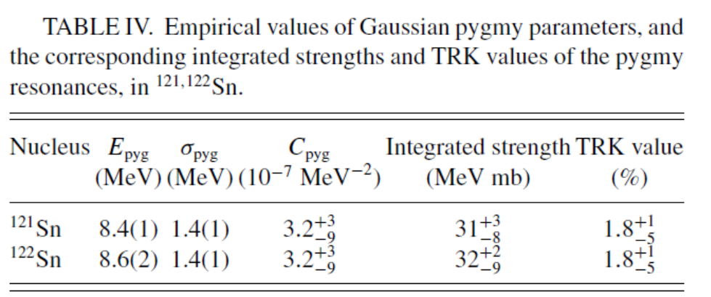
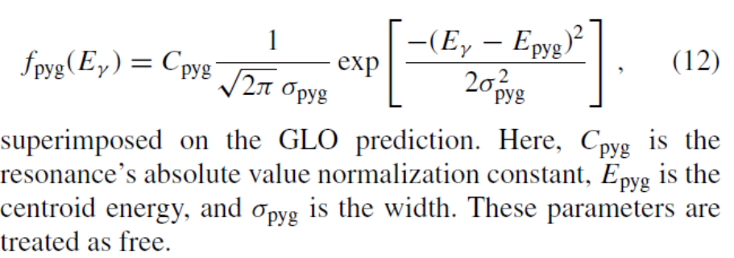

Herzberg1995

